MATLAB Assignment # 5

By: Jonathan Lopez

ECE 2010

Section B03; Mailbox # 207


Due 11/24 @ 9PM

MATLAB PROBLEM #5: DATA I/O
ECE2010 B19
Due Date – Sunday Nov 24th by 9:00 pm

Preamble
In our fifth MATLAB assignment, we will learn about basic data formats which can be used in MATLAB. It is critical in many cases to be able to read data from external devices or software and then analyze this data in MATLAB. This is what many engineers and researchers are doing all the time.
Task #1 – Review of available data formats
In Task # 1 we learn how to:
- Read/Write *.mat file (MATLAB proprietary native binary format)
- Read/Write *.txt or *.csv file (ASCII format)
- Read/Write *.xlsx file (Excel spread-sheet)

Your Task #1

Explain what the following commands (operations with importing and exporting data) "mean" by summarizing the net result of the command. If a command says to double-click on something, please double-click on the file requested in ‘Current Folder’ window.

clear all; a = [1 3 5]; b = 5; save('mydatafile', 'a', 'b');

clear all; load('mydatafile'); a, b

clc; clear all; 'then double click on mydatafile.mat';

clear all; a = [1 3; 5 7]; csvwrite('csvdata.dat', a);

clear all; a = csvread('csvdata.dat')

clc; clear all; 'then double click on csvdata.dat, click on the green checkmark in the pop-up window and close pop-up';

clc; clear all; A=magic(3); file='xlsdata.xlsx'; xlswrite(file, A)

clc; clear all; C = xlsread('xlsdata.xlsx')

clc; clear all; 'then double click on xlsdata.xlsx, click on the green checkmark in the pop-up window and close pop-up ';

x=rand(15,1); FID=fopen('ASCII.txt', 'w'); fprintf(FID,'%f\n',x); fclose(FID);

clear all; FID=fopen('ASCII.txt', 'r'); x=fscanf(FID,'%f\n'), fclose(FID);

clc; clear all; 'then double click on ASCII.txt';

1.
Clears all creates a matrix called A and b =5 this data is saved as b and a

2. returns the data stored from before. A is the matrix and b is 5
a =

1 3 5

b =

5

3. clears the command window and then right click on the saved data file and it loaded that file with the data inside

4. creates a new value of a of a new matrix

5. returns the new value of a which is a matrix
a =

1 3
5 7

6. Clears out command window and when you click on the new type of data it puts it in a table form

7. creates a new data files with a array made from the command magic 3 with takes in a 3x3 matrix and only uses number of 1 to 3^2 and they put in a table format and then into an excel spreadsheet

8. Reads the excel spreadsheet and brings in the data from it. Displays it
C =

8 1 6
3 5 7
4 9 2

9.import the data from the data sheet as they kept out the top of the matrix/ table for a 2x3 matrix

10. random number matrix 1x15 and out puts to a ascii txt file

11.
Prints out the values from the 1x15 matrix
x =

0.8147
0.9058
0.1270
0.9134
0.6324
0.0975
0.2785
0.5469
0.9575
0.9649
0.1576
0.9706
0.9572
0.4854
0.8003
12.
Opens the text of the matrix in a new MATLAB script window

Your Task #2 – Test of MATLAB readout speed/storage format

MATLAB reads large datasets very fast and stores them in a quite compact form. Using the sample script given below

clear;
N = 1e3;
A = pi*[1:N];
save('test', 'A');
clear;
tic
load test;
loadtime_sec = toc

fill out Table 1 that follows. Hint: use matlab01.wpi.edu or matlab02.wpi.edu remote servers for the best performance. For more information on remote desktop servers, see Windows Instructions and Mac Instructions on the WPI ITS Wiki.

Table 1. MATLAB data reading performance.

Number of double precision values in the array | Array read time from binary file test.mat, sec | Size of data file test.mat, Megabytes
1e4 | .0259s | .068MB
1e5 | .0300s | .597MB
1e6 | .0827s | 5.503MB
1e7 | .5958s | 50.565MB
Fill out the following table to ensure perspective on your answers. This table should be filled out under no-load conditions (i.e. don’t get these values while running your MATLAB script, the idea is to figure out how much of the server’s resources are used by other people). To find the memory and CPU use percentages, press ctrl+shift+esc (this opens Task Manager), click ‘More details’ and observe the very top of the window.
Server Name | Memory Use (%) | CPU Use (%)
matlab01.wpi.edu | 28% | 4%

Task #3 – Importing a realistic dataset

In this task, you are asked to import a surface mesh for one brain compartment: the gray matter of subject #101309 from the Population Head Repository, IT’IS Foundation, Switzerland (https://www.itis.ethz.ch/virtual-population/regional-human-models/phm-repository/)

Any triangular surface mesh (or a surface CAD object) consists of two arrays: array of nodal points P(N, 3), and array of triangle vertices (numbers) t(M, 3). You are given two data files (provided on Canvas with this assignment): GM_P and GM_t, which store these two arrays. Your goal:
- Create a separate MATLAB script. Start with clear.
2. Load the gray matter data posted along with this document.
3. Append the following code to the completed script:

screenSize = get(0, 'ScreenSize');
a = figure('Position', screenSize);
patch('Vertices', P, 'Faces', t, 'facecolor', [1 0.75 0.65]);
axis equal; axis tight; view(78, 18);

4. Run the script and obtain the corresponding figure.
5. Using figure’s data cursor, approximately mark the top of the primary motor cortex.
6. Copy the resulting figure and paste into the box given below.

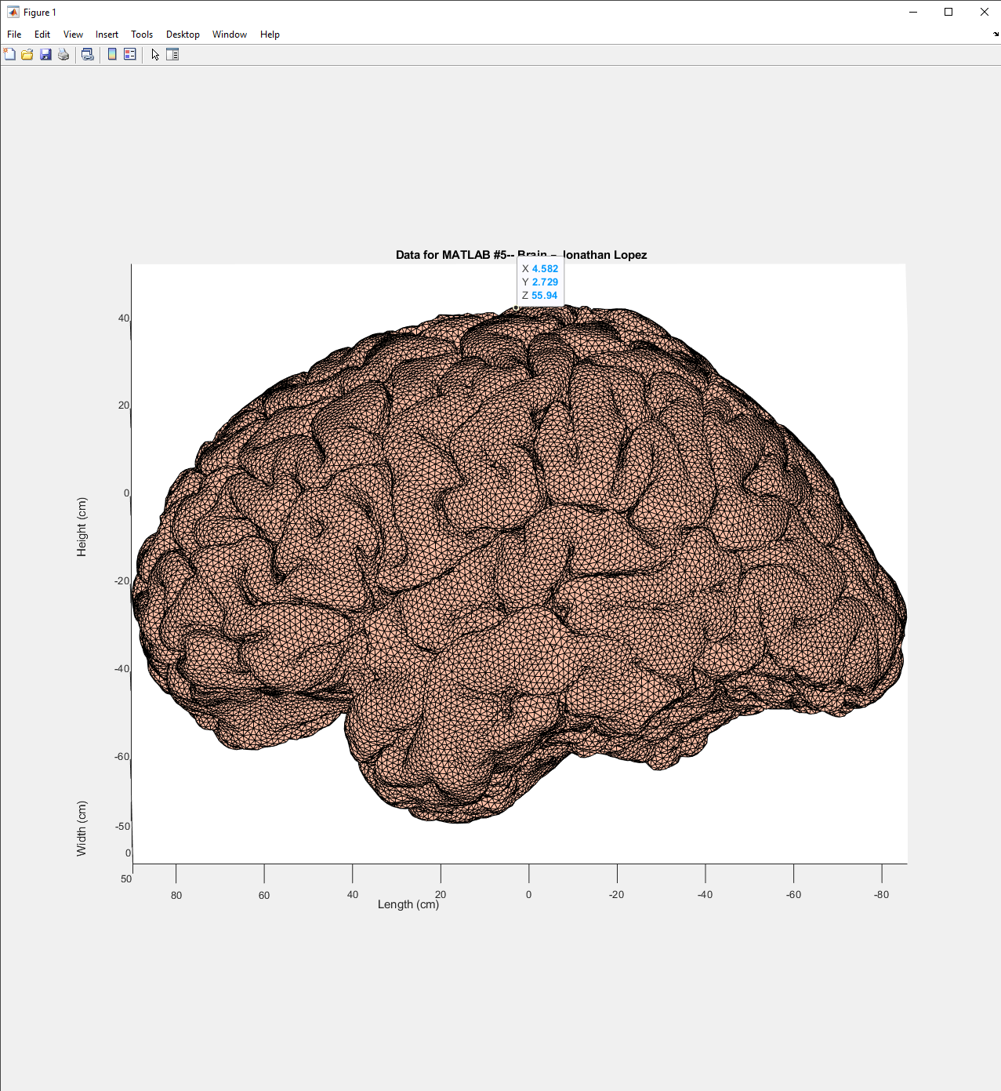

There is a MATLAB help session this coming Sunday from 7 PM to 9 PM in AK317a (the lab room).

